Decision Table Testing

Definition
# Source: AI Source: Provided by: [Data Path: Persons Table -> ID Column: 1, Name_En Column: Motasem Essam] -> From: [ChatGPT] on [8/24/2025]
Decision Table Testing is a black-box test design technique used when the behavior of the system depends on different combinations of inputs (conditions) and the resulting actions (outputs).
It’s basically a structured table that maps:
- Conditions → the different input states or rules.
- Actions → what the system should do for each combination of those conditions.

Why use it?
# Source: AI Source: Provided by: [Data Path: Persons Table -> ID Column: 1, Name_En Column: Motasem Essam] -> From: [ChatGPT] on [8/24/2025]
- It ensures you don’t miss testing any important combination of inputs.
- It’s especially useful when there are multiple business rules that interact.
- It can simplify complex logic into an easy-to-read format.

Structure of a Decision Table
# Source: AI Source: Provided by: [Data Path: Persons Table -> ID Column: 1, Name_En Column: Motasem Essam] -> From: [ChatGPT] on [8/24/2025]
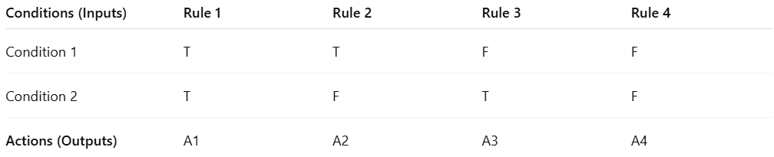
Conditions (Inputs) | Rule 1 | Rule 2 | Rule 3 | Rule 4
Condition 1 | T | T | F | F
Condition 2 | T | F | T | F
Actions (Outputs) | A1 | A2 | A3 | A4
- T/F = True / False
- Each Rule represents a test case covering that combination of conditions.

Example
# Source: AI Source: Provided by: [Data Path: Persons Table -> ID Column: 1, Name_En Column: Motasem Essam] -> From: [ChatGPT] on [8/24/2025]
Login system rule:
- If Username is correct AND Password is correct → Grant access
- If Username is correct AND Password is incorrect → Show “Wrong password”
- If Username is incorrect AND Password is correct → Show “Invalid username”
- If Username is incorrect AND Password is incorrect → Show “Invalid login”
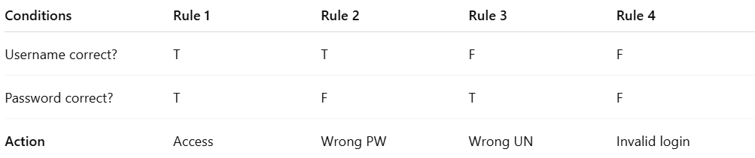
Conditions | Rule 1 | Rule 2 | Rule 3 | Rule 4
Username correct? | T | T | F | F
Password correct? | T | F | T | F
Action | Access | Wrong PW | Wrong UN | Invalid login

Testing from this table
# Source: AI Source: Provided by: [Data Path: Persons Table -> ID Column: 1, Name_En Column: Motasem Essam] -> From: [ChatGPT] on [8/24/2025]
- Test 1: Username correct, Password correct → Access
- Test 2: Username correct, Password wrong → Wrong PW
- Test 3: Username wrong, Password correct → Wrong UN
- Test 4: Username wrong, Password wrong → Invalid login

💡 Tip: Decision table testing is best when:
- There are complex business rules.
- Many conditions interact.
- You need to check all possible combinations systematically.

Coverage
# Source: AI Source: Provided by: [Data Path: Persons Table -> ID Column: 1, Name_En Column: Motasem Essam] -> From: [ChatGPT] on [8/24/2025]
In Decision Table Testing:

📌 Definition of Coverage
- The coverage items are the columns of the decision table.
- Each column represents a unique decision rule (a combination of condition values with its corresponding actions).
- Coverage = the proportion of feasible decision rules (columns) that are exercised by at least one test case.

📊 Formula
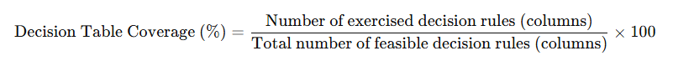
Decision Table Coverage (%)=Number of exercised decision rules (columns)Total number of feasible decision rules (columns)×100\text{Decision Table Coverage (\%)} = \frac{\text{Number of exercised decision rules (columns)}}{\text{Total number of feasible decision rules (columns)}} \times 100

✅ Example
Imagine a decision table with 2 conditions, each can be True (T) or False (F):
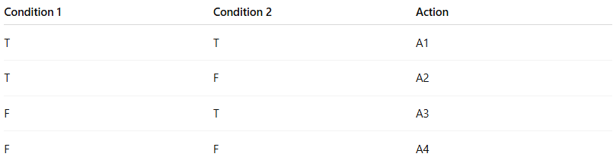
Condition 1 | Condition 2 | Action
T | T | A1
T | F | A2
F | T | A3
F | F | A4
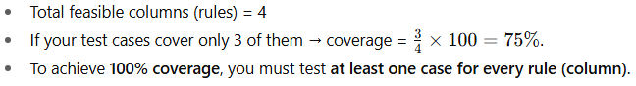
- Total feasible columns (rules) = 4
- If your test cases cover only 3 of them → coverage = 34×100=75%\frac{3}{4} \times 100 = 75\%.
- To achieve 100% coverage, you must test at least one case for every rule (column).

👉 So in short: Decision Table coverage measures how many decision rules (columns) your tests actually execute compared to how many exist.

📊 Coverage Comparison of Test Techniques
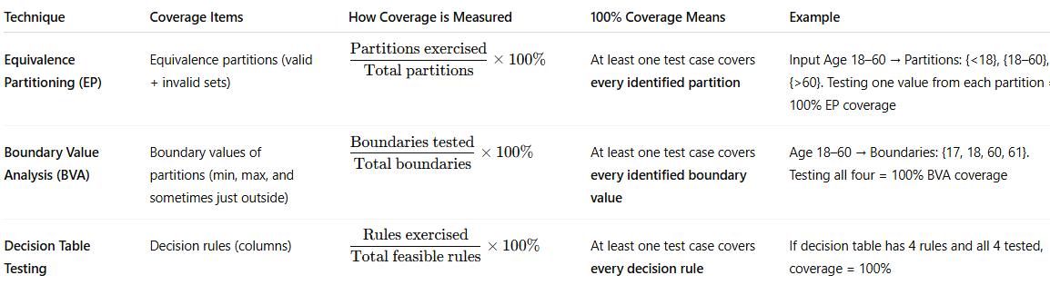
Technique | Coverage Items | How Coverage is Measured | 100% Coverage Means | Example
Equivalence Partitioning (EP) | Equivalence partitions (valid + invalid sets) | Partitions exercisedTotal partitions×100%\dfrac{\text{Partitions exercised}}{\text{Total partitions}} \times 100\% | At least one test case covers every identified partition | Input Age 18–60 → Partitions: {<18}, {18–60}, {>60}. Testing one value from each partition = 100% EP coverage
Boundary Value Analysis (BVA) | Boundary values of partitions (min, max, and sometimes just outside) | Boundaries testedTotal boundaries×100%\dfrac{\text{Boundaries tested}}{\text{Total boundaries}} \times 100\% | At least one test case covers every identified boundary value | Age 18–60 → Boundaries: {17, 18, 60, 61}. Testing all four = 100% BVA coverage
Decision Table Testing | Decision rules (columns) | Rules exercisedTotal feasible rules×100%\dfrac{\text{Rules exercised}}{\text{Total feasible rules}} \times 100\% | At least one test case covers every decision rule | If decision table has 4 rules and all 4 tested, coverage = 100%

✅ Quick takeaway:
- EP → “Did I test at least one value from each partition?”
- BVA → “Did I test at least one value from each boundary?”
- Decision Table → “Did I test at least one case for each decision rule?”

Alright 👍 let’s go through a practical example of Decision Table Testing coverage step by step.

🎯 Example: Loan Approval System
Suppose a loan is approved based on:
- Condition 1: Applicant has a stable income (Yes/No)
- Condition 2: Applicant has no existing debts (Yes/No)
Step 1: Build the Decision Table
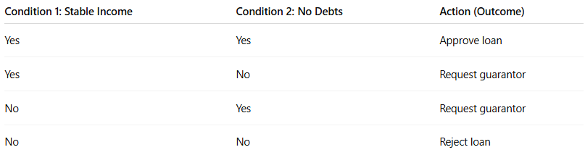
Condition 1: Stable Income | Condition 2: No Debts | Action (Outcome)
Yes | Yes | Approve loan
Yes | No | Request guarantor
No | Yes | Request guarantor
No | No | Reject loan
👉 This table has 4 decision rules (columns).

Step 2: Identify Coverage Items
- Coverage items = the 4 rules/columns.

Step 3: Apply Coverage
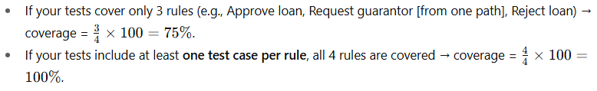
- If your tests cover only 3 rules (e.g., Approve loan, Request guarantor [from one path], Reject loan) → coverage = 34×100=75%\frac{3}{4} \times 100 = 75\%.
- If your tests include at least one test case per rule, all 4 rules are covered → coverage = 44×100=100%\frac{4}{4} \times 100 = 100\%.

✅ Summary
- Coverage items = columns (decision rules).
- 100% Decision Table Coverage = test cases exercise all feasible decision rules in the table.

